**TX Blocks**

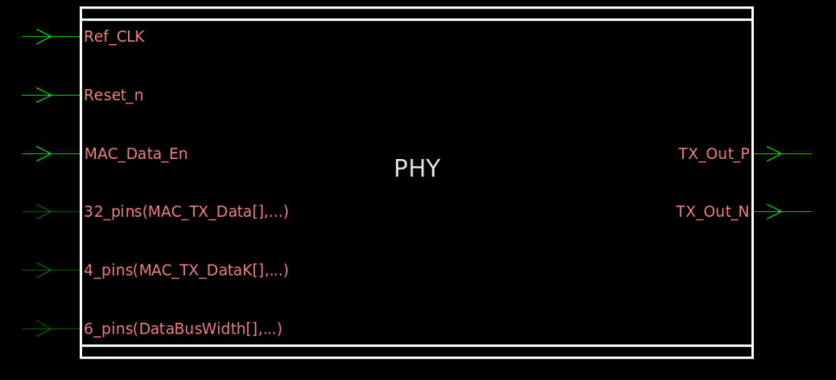

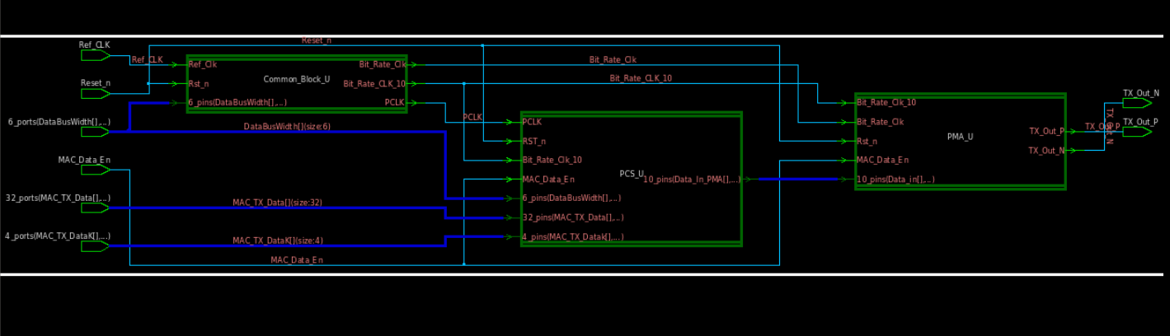

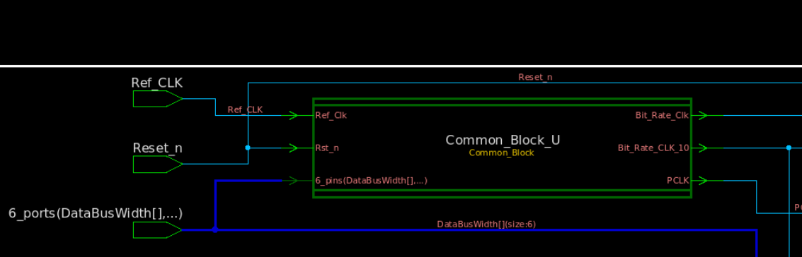

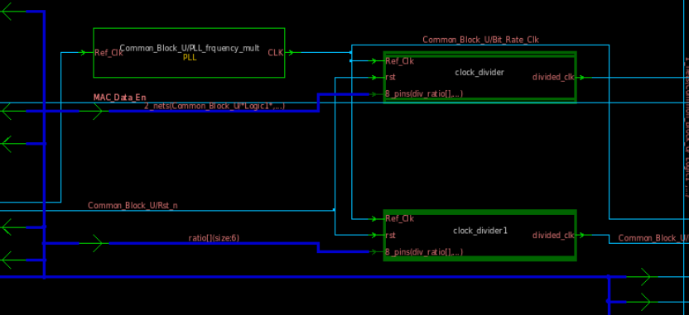

|  |  |  |
| --- | --- | --- |
| Port | Width | Type |
| Ref_CLK | 1 | Input |
| Rst_n | 1 | Input |
| DataBusWidth | 6 | Input |
| Bit_Rate_Clk | 1 | Output |
| Bit_Rate_CLK_10 | 1 | Output |
| PCLK | 1 | Output |

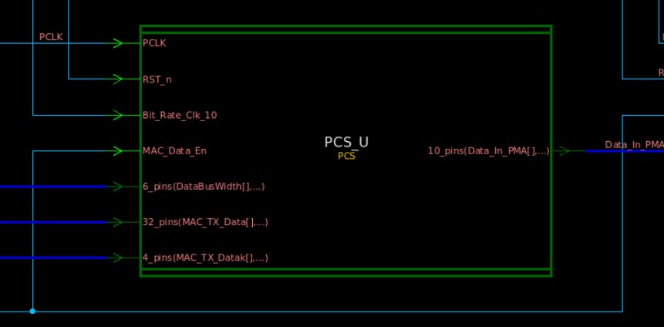

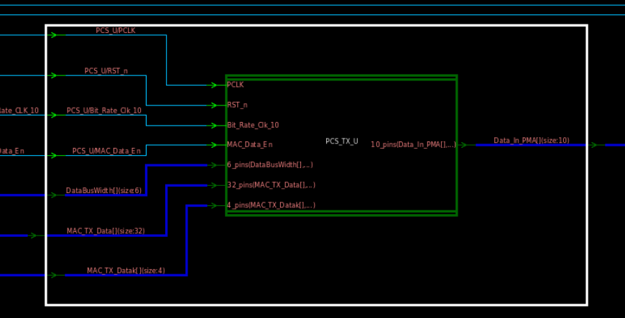

|  |  |  |
| --- | --- | --- |
| Port | Width | Type |
| PCLK | 1 | Input |
| RST_n | 1 | Input |
| Bit_Rate_Clk_10 | 1 | Input |
| DataBusWidth | 6 | Input |
| MAC_TX_Data | 32 | Input |
| MAC_TX_Datak | 4 | Input |
| MAC_Data_En | 1 | Input |
| Data_In_PMA | 10 | Output |

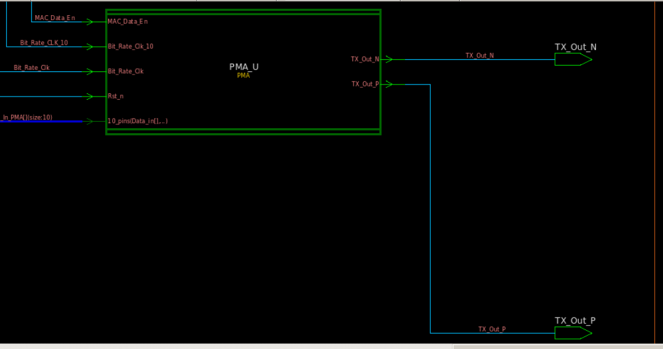

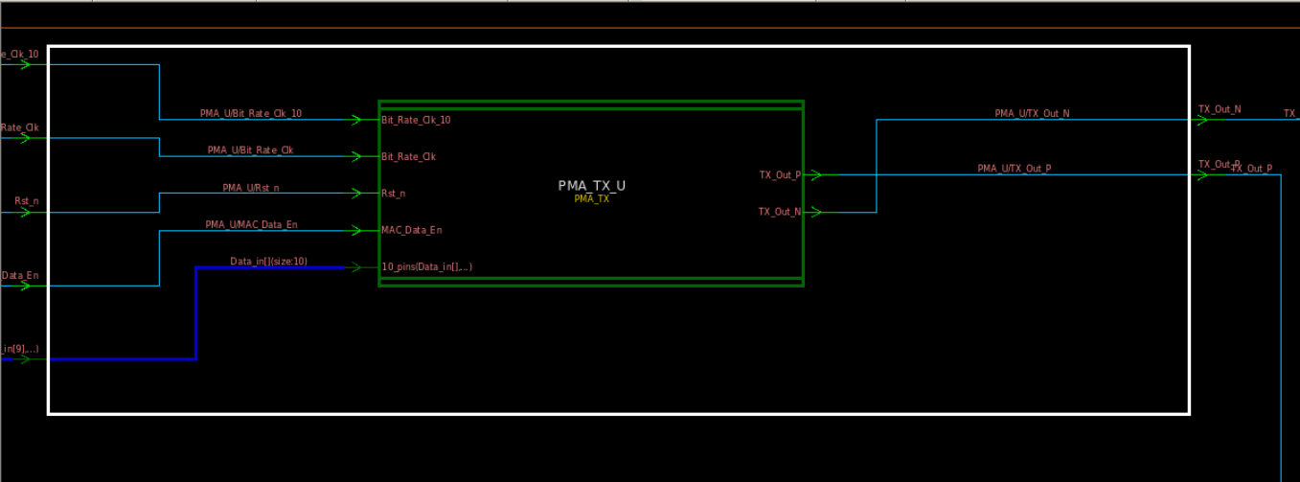

|  |  |  |
| --- | --- | --- |
| Port | Width | Type |
| Bit_Rate_Clk_10 | 1 | Input |
| Bit_Rate_Clk | 1 | Input |
| Rst_n | 1 | Input |
| MAC_Data_En | 1 | Input |
| Data_in | 10 | Input |
| Tx_Out_P | 1 | Output |
| Tx_Out_N | 1 | Output |